A Novel Approach to Implement Soil Carbonation for Subgrade Stabilization
SK Belal Hossen, EI, PhD candidate, Civil and Environmental Engineering, University of Maine.
Aaron P. Gallant, PhD, PE, Assistant Professor, Civil and Environmental Engineering, University of Maine.
Warda Ashraf, PhD, Assistant Professor, Department of Civil Engineering, Center for Advanced Construction Materials (CACM), University of Texas at Arlington, Texas.

Abstract
Accelerated soil carbonation showed promising results to improve the soil strength and stiffness on the laboratory scale. This alternative ground improvement technique (i.e. soil carbonation) consumes carbon dioxide (CO₂) gas into subgrade soils via carbonate binder precipitation and gains relatively faster strength improvement. Elemental testing revealed that the carbonation of hydrated lime, Ca(OH)₂, mixed (10% by weight) soils (both sand and silt) at low pressure (10-15 kPa) could attain unconfined compressive strength (UCS) of 3-3.5 MPa with a degree of carbonation about 80% in 72-120 hours at the optimum initial state of soils (e.g. degree of saturation and dry density). Therefore, this study aimed to investigate the potential method to implement soil carbonation for stabilizing subgrade soils that support transportation infrastructure. A large-scale soil box (length, width, and height are 2 m, 1 m, and 0.75 m, respectively) experiment is being conducted to evaluate the field performance of soil carbonation. This presentation will cover a detailed methodology that has been adopted to introduce gaseous CO₂ into subgrade soils. It will also present the techniques to evaluate the spatial and temporal changes in binder precipitation and soil stiffness during carbonation as well as to measure the overall mechanical strength improvement and calcium carbonate binder content with the gas loss after the carbonation.
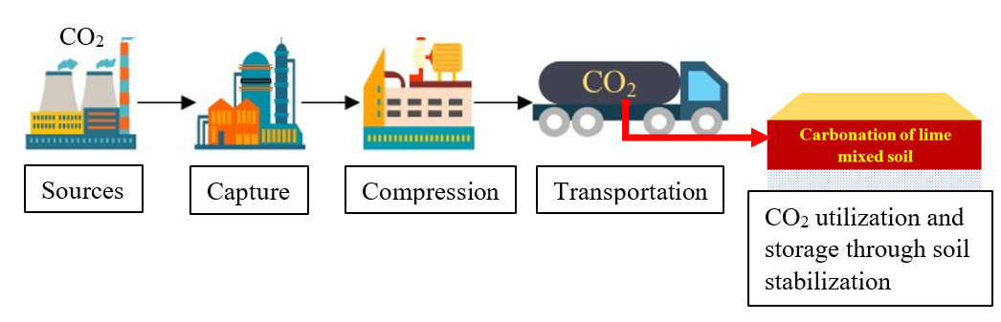
Figure 1. Application of Carbon Capture, Utilization, and Storage (CCUS) concept in ground improvement: accelerated carbonation of lime mixed soil for calcium carbonate binder precipitation to stabilize the subgrade soils.

Acknowledgements: Funding for this research is provided by the Transportation Infrastructure Durability Center at the University of Maine under grant 69A3551847101 from the U.S. Department of Transportation’s University Transportation Centers Program. The authors would like to sincerely appreciate the in-kind support of the Advanced Structure and Composite Center (ASCC) and Office of Facilities Management at the University of Maine and R.W. Gillespie & Associates, Inc, Biddeford, ME.

