**Development of Protocols for Determining Deleterious Material Content in Processed Glass Aggregate**

Fiona Nutbeam, Dr. Matthew Scarborough, Dr. Mandar Dewoolkar, Department of Civil & Environmental Engineering, University of Vermont

**Abstract**

Single-stream recycling leads to a portion of glass that cannot be recycled into new glass. At the Chittenden Solid Waste District, glass is turned into processed glass aggregate (PGA). Both coarse and fine aggregates are produced and fine PGA has a similar gradation to sand. Previous literature suggests that PGA may have similar properties to sand and be suitable as a sand replacement. One major reason that PGA is not yet widely used as a construction material is a lack of proven methods to accurately determine the deleterious content (e.g., plastics, paper, metals) of PGA. This research proposes to address the need for a reliable deleterious content test by investigating multiple processes for determining deleterious material content in PGA. These mass removal processes will be developed into multi-process protocols that can reliably determine deleterious material content. Currently identified deleterious material content determination processes include floating and skimming; (2) combustion at 550°C; (3) magnetic separation; (4) dissolution and phase separation with xylene; (5) acid washing with sulfuric acid; (6) organics removal with Fenton’s reagent. Preliminary data on recycling facility PGA has indicated that PGA has similar geotechnical properties to sand borrow. The float and skim process and combustion at 550°C process is able to remove some but not all deleterious material. Additional potential processes are being researched.

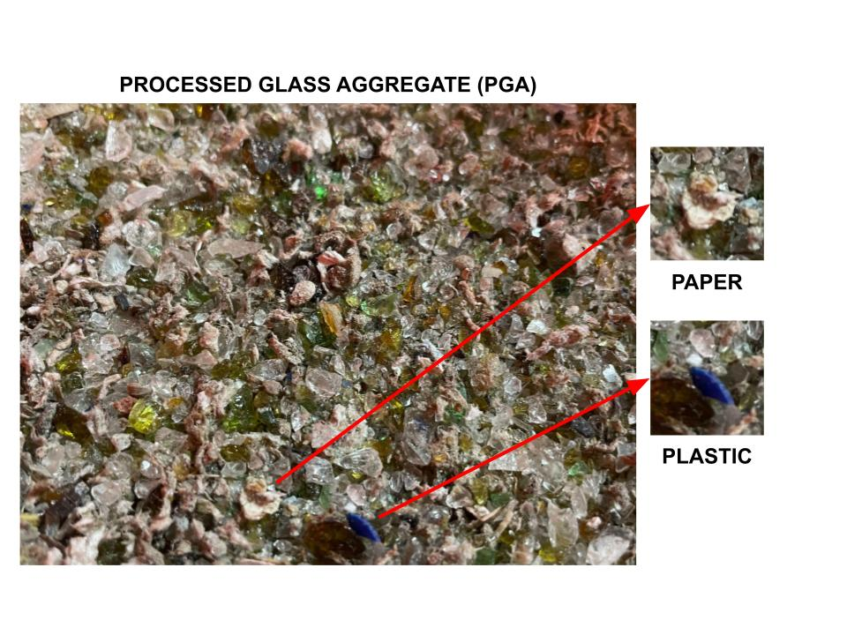

**Acknowledgements:** Special thanks to Dr. Matthew Scarborough and Dr. Mandar Dewoolkar for their help and contribution to this research. ​The author is grateful to Dr. Gregory Rowangould, Dr. Ehsan Ghazanfari, and Dr. Rory Waterman for their feedback. Thanks to Brandon Nimberger, Harrison Lucas, and Eric Licho for their work providing additional information on the properties of PGA. Funding for this research is provided by the Transportation Infrastructure Durability Center at the University of Maine under ​grant 69A3551847101 from the U.S. Department of Transportation’s ​University Transportation Centers Program. Additional financial support is provided by Chittenden Solid Waste District and the helpful feedback of Josh Tyler is appreciated. In-kind support by VTrans and engagement of VTrans personnel, August Arles, Callie Ewald, Nick Van Den Berg, Tanya Miller, Dr. Emily Parkany, and Dr. Ian Anderson, and VTANR personnel, James Surwilo, are much appreciated.  ​

**References**

[1] Glass Packaging Institute. (2021). *Glass recycling facts*. Glass Packaging Institute. Retrieved October 2021, from https://www.gpi.org/glass-recycling-facts.