Lateral Spreading and Basal Stability of Column-
Supported Embankments
Graduate student Danilo Botero-Lopez, Ph.D. Aaron P. Gallant, Civil and Environmental Department of University of Maine

Abstract: Column-support is used to accelerate construction over soft ground. These columns are unreinforced high-modulus elements. It has been recommended by some that column fracturing should be avoided altogether due to the perception that column fracturing is either a major culprit, or indication of, lateral instability in the foundation materials. The goal of this study is to determine if these elements can tolerate some degree of cracking and safely support embankments. A 3D parametric Finite Element (FEM), which incorporated a method to account for the cessation of bending resistance when column cracking was predicted, was performed. The influence of area replacement, soft clay type, and crust thickness were examined to address the factor of safety and predicted lateral spreading. Based on the numerical results, two observations were made: i.) Lateral spreading analyses --- recommended by FHWA ---- are akin to sliding check at the base of fill, which neglect the restraint and influence of crust thickness at the toe and potential strain discontinuities and slip surfaces that develop at depth in weaker soil (Figure 1); ii.) If subsurface conditions provided adequate confinement, justified based on a factor of safety for basal instability, some degree of column fracturing can be tolerated. This understanding can be used to optimize area of replacement and/or justify elimination of steel reinforcement in perimeter columns to increase construction efficiencies.

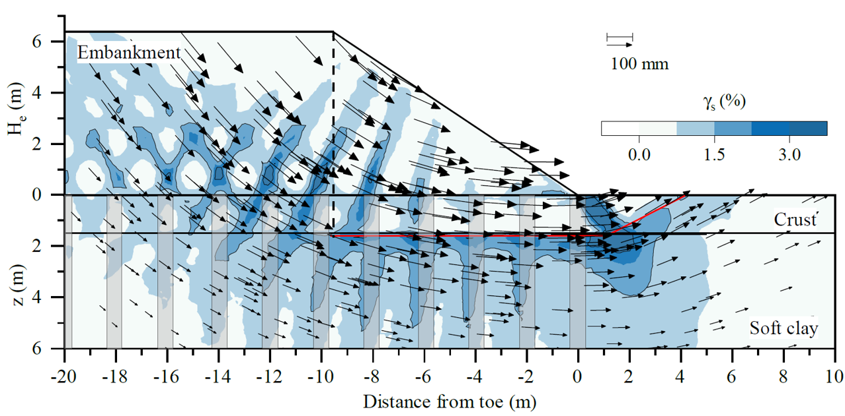
Figure 1. Shear strains and displacements vectors obtained via FEM.
Acknowledgements: This project was financially sponsored by the Deep Foundation Institute’s and the Transportation Infrastructure Durability Center (TIDC) at University of Maine.

