Noncontact Bridge Assessment via Computer Vision and Artificial Intelligence
Celso T. do Cabo, Dr. Zhu Mao, Department of Mechanical Engineering, University of Massachusetts Lowell, Lowell, MA, United States
Abstract

The applicability of camera-based sensing techniques has proved to be an effective technology to extract dynamic information. Compared to traditional sensing techniques, which requires a permanent installation in the structure, posing a high maintenance cost and large amount of time for the installation. The optical based systems pose a portable and low-cost method for Structural Health Monitoring (SHM). Among the techniques to process camera data available, Phase-based Motion Extraction (PME) and Magnification (PMM) shows great capability to extract natural frequencies and amplify its subtle (invisible) motions, allowing the extraction of full-field mode shapes from structures. For infrastructure applications, PME and PMM showed great applicability, having a small setup time and not requiring to stop traffic operation in the structure for setup and testing. It also demonstrated good accuracy if compared with different sensing modalities. For instance, tests were performed with a commercial camera-based systems, developed by RDI as shown in Figure 1 and also to strain-gauge data along with PME and PMM. In addition, the enhanced movement extracted from the PMM algorithm, proved to increase the feasibility of data-driven algorithms to detect damage for the lab-scale tests. Allying Convolutional Neural Networks (CNN) with Long-Short Term Memory (LSTM) networks it was possible to extract features from the frames and time correlate the change of features between frames. The algorithm showed an extraordinary capability to classify damage from the videos obtained after the application of PMM, showing great potential to be applied into operational bridges.
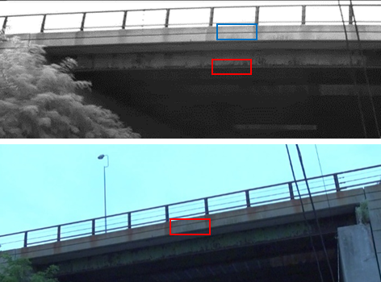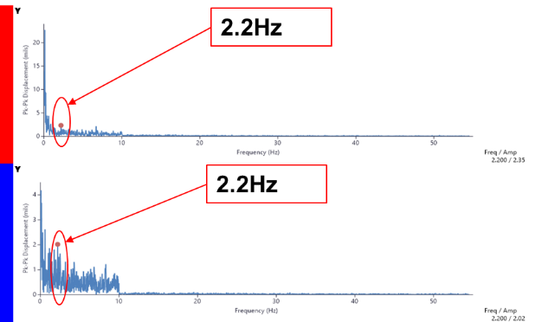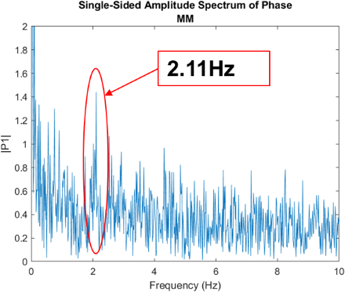
- (b) (c)
Figure 1: (a) Field of view from RDI systems (top) and PME (bottom), and vibration power spectrum in frequency domain for (b) RDI systems and (c) PME

Acknowledgements: This project was financially sponsored by the Transportation Infrastructure Durability Center at the University of Maine under grant 69A3551847101 from the U.S. Department of Transportation’s University Transportation Centers Program.

